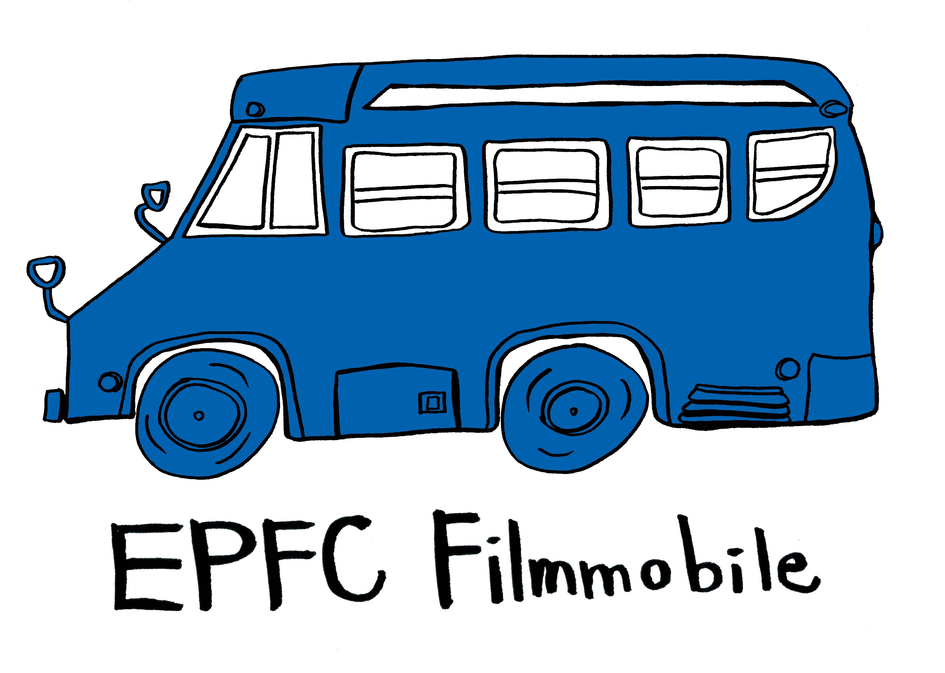

Echo Park Film Center Presents
The EPFC Filmmobile 2011 National Tour

2011 National Tour
Join us this summer as the EPFC Filmmobile brings the magic of the moving image coast to coast from June 26 to August 3!

About the Echo Park Film Center
Echo Park Film Center is a non-profit media arts organization committed to providing equal and affordable community access to film/video resources via five channels: a neighborhood microcinema, free and nominal cost education programs, a full-service retail department, a green-energy mobile cinema & film school, and a touring film festival showcasing local established and emerging filmmakers. This year marks EPFC’s 10th anniversary and we’re bringing the celebration to your town!

About the EPFC Filmmobile
The Filmmobile takes Echo Park Film Center programs on the road to better serve our own community and facilitate exchanges with communities beyond the boundaries of Echo Park. Working in conjunction with local innovators in mobile media and clean energy technology, we transformed a 1997 Bluebird into the EPFC Filmmobile: a full-service, eco-friendly screening and educational facility on wheels. The Filmmobile is completely self-contained and operates off the grid; we carry all the necessary equipment to make and project films with power coming from solar power and a small generator.

Filmmobile programs focus on free film screenings in non-traditional venues (parking lots, vacant lots, parks, etc.) for the general public and free filmmaking workshops for media-marginalized populations, specifically at-risk youth, girls and young women, recent immigrants, the homeless, seniors, people of color and low-income earners. These programs provide a fertile meeting space for skills building and the exchange and validation of ideas, knowledge, and experiences, empowering individuals to share their unique stories with the world. Running on waste-vegetable oil, the bus itself serves as a model of sustainability while simultaneously regenerating the long and noble tradition of itinerant cinema.

SCREENINGS AND WORKSHOPS
In addition to projecting a delightful array of experimental short films, live music and bingo under the stars, we’re offering two terrific filmmaking classes: make a movie without using a camera in the Direction Animation Chain Letter workshop or learn the basics of stop motion animation at the Photobooth of Change Workshop… Films created during the afternoon workshops will be included in the evening screenings.
All events are free! Everyone welcome!

More information: www.filmmobile.org and www.echoparkfilmcenter.org
For exact show times and locations, follow us on Twitter @EPFCFilmmobile
Contact Paolo Davanzo and Lisa Marr by sending a message on Facebook:
https://www.facebook.com/echoparkfilmcenter
https://www.facebook.com/filmmobile

2011 Filmmobile Summer Tour Itinerary
Monday, June 27: Gilbert, AR – Art Intersection
Tuesday, June 28: Santa Fe, NM – Warehouse 21
Thursday, June 30: Fort Worth, TX - street screening
Friday, July 1: Dallas, TX – Kessler Theater
Saturday, July 2: Shreveport, LA – Mini Cine
Sunday, July 3: New Orleans, LA – street screening
Monday, July 4: New Orleans, LA – street screening
Tuesday, July 5: Birmingham, AL – Sidewalk Moving Picture Festival Sidewalk Salon
Thursday, July 7: Asheville, North Carolina - Trainyard
Friday, July 8: Durham, North Carolina – street screening
Saturday, July 9: Washington, DC – street screening
Sunday, July 10: Baltimore, Maryland – American Visionary Art Museum
Monday, July 11: Philadelphia, Pennsylvania – street screening
Tuesday, July 12: Harlem, New York - Maysles Institute
Wednesday, July 13: Brooklyn, New York – Union Docs
Thursday, July 14: New Bedford, Massachusetts – ArtWorks!
Friday, July 15: Syracuse, New York - Everson Museum
Saturday, July 16: Rochester, New York - Visual Studios Workshop
Sunday, July 17: Buffalo, New York – The Squeaky Wheel
Monday, July 18: Cleveland, Ohio – street screening
Tuesday, July 19: Detroit, Michigan – street screening
Wednesday, July 20: Detroit, Michigan – Mt. Elliot Makerspace
Friday, July 22: Chicago, Illinois – Chicago Filmmakers
Saturday, July 23: Chicago, Illinois – Golden Age
Sunday, July 24: Madison, Wisconsin – Project Lodge
Monday, July 25: Milwaukee, Wisconsin – Lynden Sculpture Garden
Wednesday, July 27: Minneapolis, Minnesota – street screening
Thursday, July 28: Minneapolis, Minnesota – Walker Art Center
Sunday, July 31: Boulder, Colorado – Handmade Film Institute
Monday, August 1: Boulder, Colorado – street screening
Tuesday, August 2: Salt Lake City, Utah – Spy Hop Productions

CINEMA PROGRAM
Bateau D’Amour – Anabel Curry, 2005, 2:18 - claymation
Butterfly – Duncan Martinez, 2:33, 2008 – cell animation
The Distant – Jason Harris, 4:00, 2003 – stop motion animation
50 Feet That Shook The World – John Cannizzaro, 2:45, 2004 - Super 8 stop motion
Flower Valley – Joel Fox, 2002, 3:08 – computer animation
Flying Rat – Cosmo Segurson, 2007, 4:07 – hand-processed 16mm film
The Fridge – Lucie Stamfestova, 7:00, 2007 – stop motion animation
The Garden – Randall Rickert, :30, 2007 – computer animation
Garden Bandit – Ashley Ruiz, :30, 2010 – cutout animation
Hitchcock – Miles Crist, :30, 2010 – cutout animation
Mis Manos – Walter Vargas, 5:00, 2010 – Super 8 film & digital video
Mjamjam – David Pfluger, 2:55, 1999 – Super 8 film
On This Day – Naomi Uman, 4:00, 2008 – 16mm film
Passive Anarchy – Paolo Davanzo, 8:00, 1998 – 16mm film
6 Astronauts – Dagie Brundert, 6:00, 1992 – Super 8 stop motion animation Smoking Yoga – Billy Childish, 2:30, 2002 – Super 8 film
The Sound We See – EPFC Youth Class, 28:00, 2011 - 16mm film
This Is The LA River – EPFC Youth Class, 30:00, 2007 - 16mm film
Tiny Planet – Joe Hilsenrad, 5:00, 2001 – Super 8 film
World On Wheels – The Here & Now, 2:27, 2007 – Super 8 cut out animation

